Lab 3 – Georectifying and Digitizing Images

## Background

Old maps and aerial photos can be an incredible source of information for civil and environmental engineers. There are thousands of filing cabinets, in government agencies and engineering consulting firms, that are filled with mapping data in paper form. This data can be used to help us better understand things such as:

* How cities and landscapes have changed or evolved over time
* How growth patterns are affected by natural and manmade geospatial features
* Effects of climate change on natural systems
* Impact of public transportation and other infrastructure on city planning

With the advent of inexpensive online storage space and thanks to major efforts by libraries and other agencies, old maps and aerial photos are more readily available online than ever before.

## Problem Statement

Let’s assume two different scenarios:

1. You need to identify the locations of some old historic cities that no longer are populated or show up on modern maps
2. You need to identify the location of some old streets in an old European city that might not exist today

In both cases, the goal is to create vector shapefiles of the identified features. These shapefiles need to be created through a process of digitizing. Digitizing is where you identify the features on a map and then draw the features on a shapefile layer. Before you can do that, you need to georeference your old map. This means to place it in the correct place on the earth. When you draw features on a shapefile using the map for reference, your features will show up in the right place.

## Procedure

You will work individually on this exercise and for all future laboratory exercises. You will need to repeat the following steps for each map you create. Your U.S. state map should be dated earlier than 1900 and your European city map earlier than 1800. These maps will give you the best results in identifying changes between the basemaps. If you are having troubles finding a map older than 1900, try to find the closest map you can to that time period. The farther back in time your map represents, the more changes you will be able to find between then and now.

### Step 1

Research and find a scanned historic map of a city or state of your choice. Make sure that the map has high resolution and is legible. These are some sources you can use to find an appropriate map:

* <https://images.google.com/>
* <https://historicalmaps.arcgis.com/usgs/>
* <https://nationalmap.gov/historical/>
* <http://geonames.usgs.gov/apex/f?p=262:18:0::NO:RP%2C18>

Download the scanned image of the map and save it to your computer. It is possible that the file you download will be a PDF. If this is the case, you will need to convert the PDF file to a JPG file. You can do this by using Adobe Acrobat Reader or a free online converter. Here is a suggested online converter: <https://pdf2jpg.net/convert.php#.W0TZSNJKiM8>.

### Step 2

Start ArcGIS Pro, open a new blank map document, and add a basemap.

### Step 3

Make a folder connection to the folder that contains the JPG file you saved. Drag the file from the **Catalog** pane to the **Content** pane to add it to your map. The historic map does not know where it is supposed to be located. If you right-click and **Zoom to Layer**, you will notice that the historic map is floating somewhere random on the globe. For example, next to Africa.

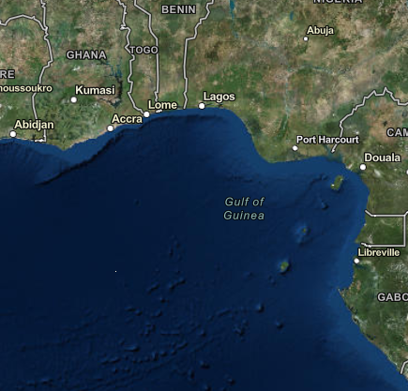

My Historic Map

Figure : Random Location of Historic Map

You are going to use the georeferencing tool to pin the historic map on top of the ArcPro Map.

On the ArcPro Map, navigate to the general area of where the scanned map is located. Open the **Imagery Tab** and click on the **Georeference** button. This will open the georeferencing ribbon.

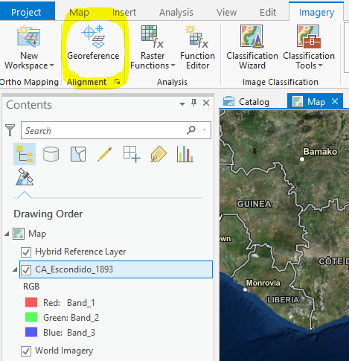

Figure 2 – Screenshot showing where to find the Georeferencing button.

In the **Prepare Group**, click the **Fit to Display** button. The scanned map will move to the area you previously navigated to. This is your first attempt to locate your scanned map on top of the ArcPro Map. On the **Appearance Tab**, in the **Effects Group**, you can change the transparency so that you can see what you are georeferencing. You can also check the layer on and off to see behind the image.

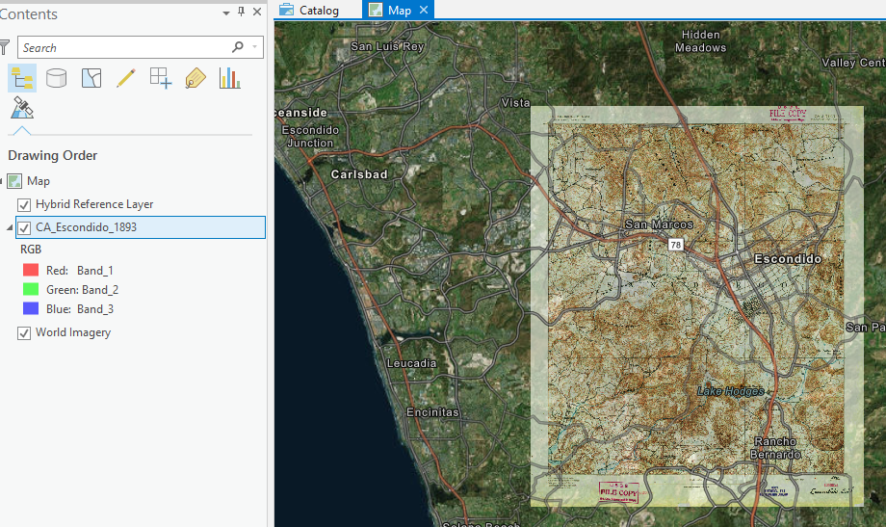

Figure 3: Fit to Display and Transparency

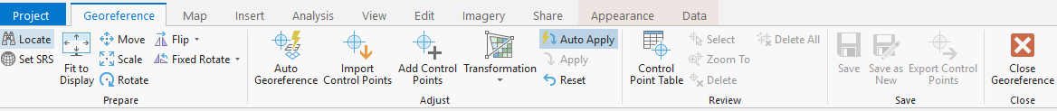

Figure 4 – Screenshot showing Georeferencing toolbar.

### Step 4

On the **Georeferencing Tab**, in the **Adjust Group**, click **Add Control Points**. Click a defined corner or intersection on the image and match it to the same location on the basemap.

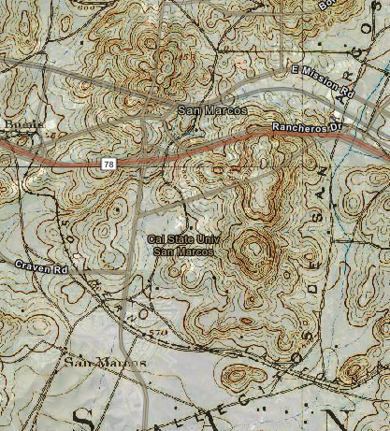

Basemap Reference

Historic Map Reference

Figure : Example of reference points

You may need to add several control points to get your map to line up properly on the basemap. After lining up your image with the basemap, be sure to click **Save** on the Georeferencing toolbar to save the georeferencing position.

### Step 5

Identify a few point or polyline features on your historic image (e.g. locations, cities, or roads) that are not present on a modern map. You can explore different modern maps by changing the basemap display. In the **Catalog** pane, under the **Databases** category, right-click on the geodatabase created for your lab, scroll down to **New**, and click **Feature Class**. Create a new point or polyline shapefile with the same projection as your current data frame view.

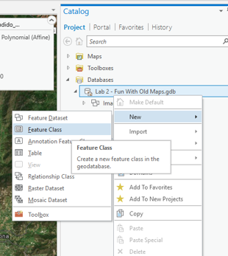

Figure 6 – Screenshot showing how to start creating a shapefile.

Select the layer you just created, open the **Edit** tab, and click **Create** under the **Features** group. Use the **Create Features** pane to edit the new feature class and add the specific point and polyline features you identified. Be sure to click **Save** to save your edits when you are finished. For a more extensive review of editing a shapefile, refer to the Basic Skills chapter.

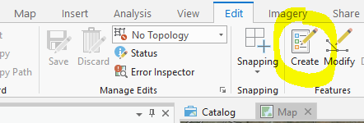

Figure 7 – How to start editing a shapefile.

### Step 6

You will want to add labels for the locations or roads you identified in your feature class. Right-click on your feature layer and open the **Attribute Table**. Click on the **Add** field button. Add a field called Location_Name with the data type set to Text. Switch back to the **Attribute Table** and name the locations accordingly.



Figure : How to get to the add field table

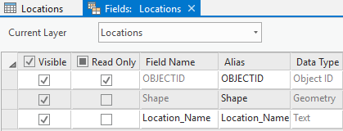

Figure : Add Field

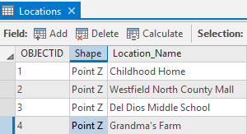

Figure : Filling New Field in Attribute Table

Make sure that the feature layer is still selected in the **Contents** pane. On the ribbon click the **Labeling** tab and click **Label.** Check the **Label Features in this Class.** In the **Field** drop-downselect Location_Name.

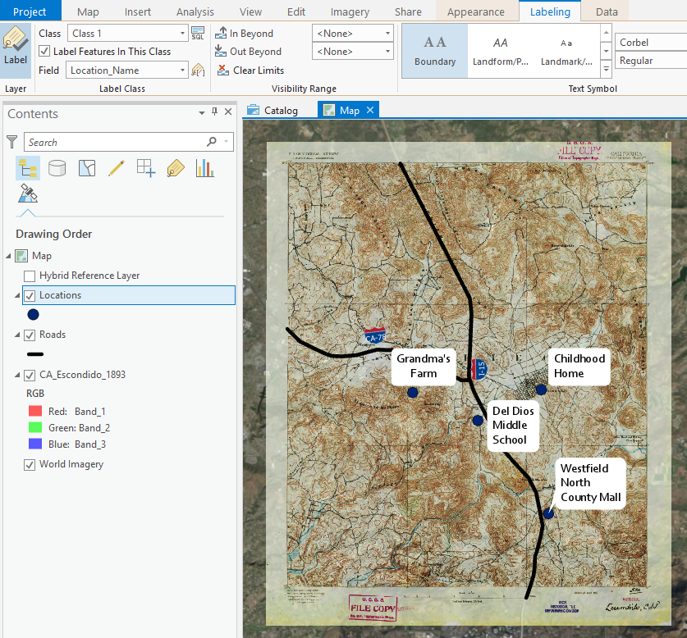

Figure : Labeling

## Deliverables

Prepare and submit a brief report discussing your project and presenting your results. The project should be about 3 pages long, including your two full-page maps. Your project report needs to indicate where you got the original maps, what basemap you used for georeferencing, how many rectification nodes you used to georeference your images, and discuss the results. You should show two full page (8.5 ­x 11) maps that present 3 layers: the basemap, the georeferenced old map, and the digitized features. Your maps should include all of the required elements of a good map as noted in the grading rubric. Make sure to review over the rubric at the end of this chapter for the full requirements for the laboratory exercise.

## Example Map of Missing Cities in a U.S. State

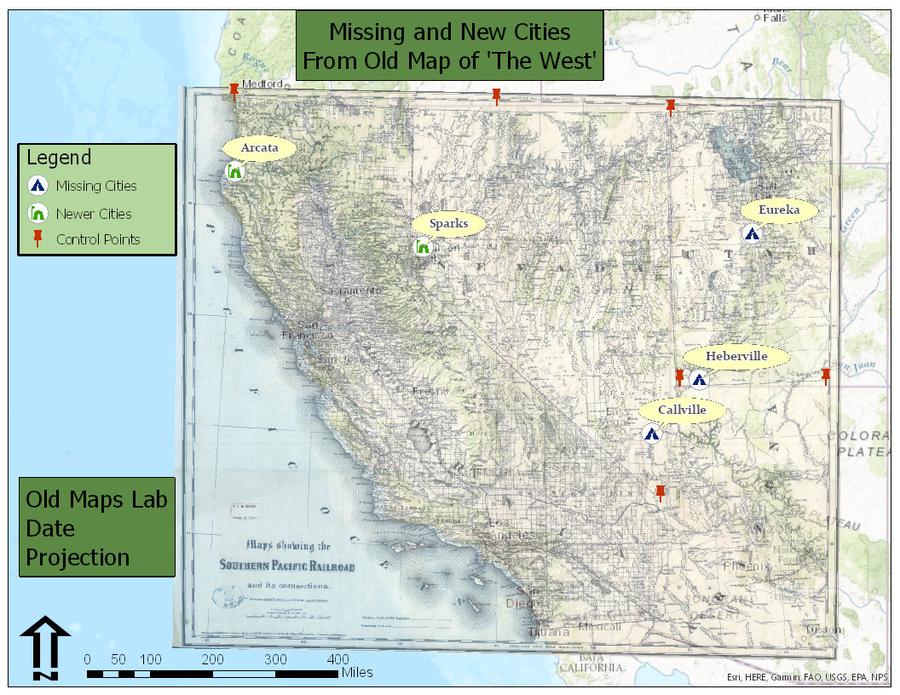

Source of georeferenced map: [http://usgwarchives.net/maps/utah/images/west1876.jpg](http://usgwarchives.net/maps/utah/images/west1876.jpg%20)

## Example Map of Missing Roads in European City

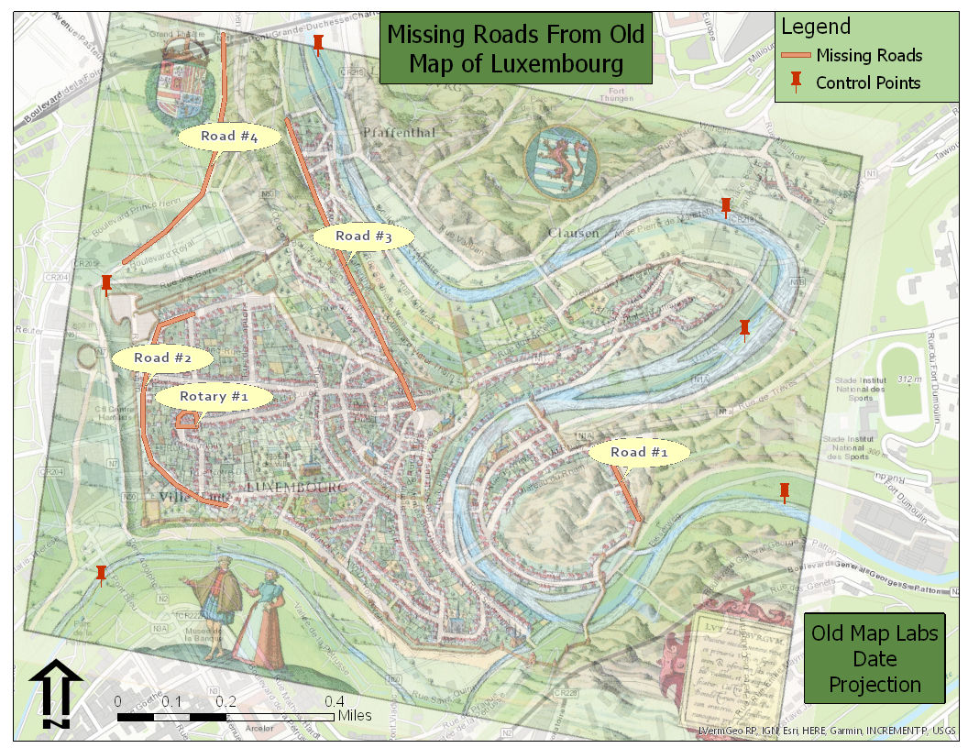

Source of georeferenced map: <https://img0.etsystatic.com/114/0/7893465/il_fullxfull.858391386_gp92.jpg>

## Rubric for Fun with Old Maps

|  |  |
| --- | --- |
| **Item** | **Points** |
| Assignment Title, Name, Date, Course Name | /4 |
| Brief summary of the requirements of the project | /4 |
| Give the sources for both of the old maps that were found | /4 |
| List the number of georectification nodes used to rectify each image | /4 |
| List and describe the specific features that were found and digitized from each old map. | /4 |
| Make two full page (8.5 x 11) maps, one for each old map   * Show georeferenced old map, digitized features, and control points used: (5 pts.) * Map Title: (1 pt.) * Neat Line: (1 pt.) * North Arrow: (1 pt.) * Scale Bar: (1 pt.) * All digitized features are labeled: (1 pt.) * Text box with author name, date, map projection: (1 pt.) * Digitized features marked with a well-defined symbol: (1 pt.) * Background map is visible: (1 pt.) * Zoomed to an appropriate scale for viewing all features: (1 pt.) * All text is legible on printed map: (1 pt.) | State Map  /15 |
| City Map  /15 |
| **Bonus Task:** Repeat the lab exercise with a different dataset. Include in your report what data you used, how you acquired it, and what you may have changed to complete the exercise. Include an additional full-page map showing your results. | Instructor’s  Discretion |